**Machine Learning with Pyspark**

**Student Name: Nabh Sanjay Mehta Student Id: NSM190002**

**Date: 04/24/2020**

Part 1: Create a databricks account.

Step 1: Open the link:

<https://community.cloud.databricks.com/login.html>

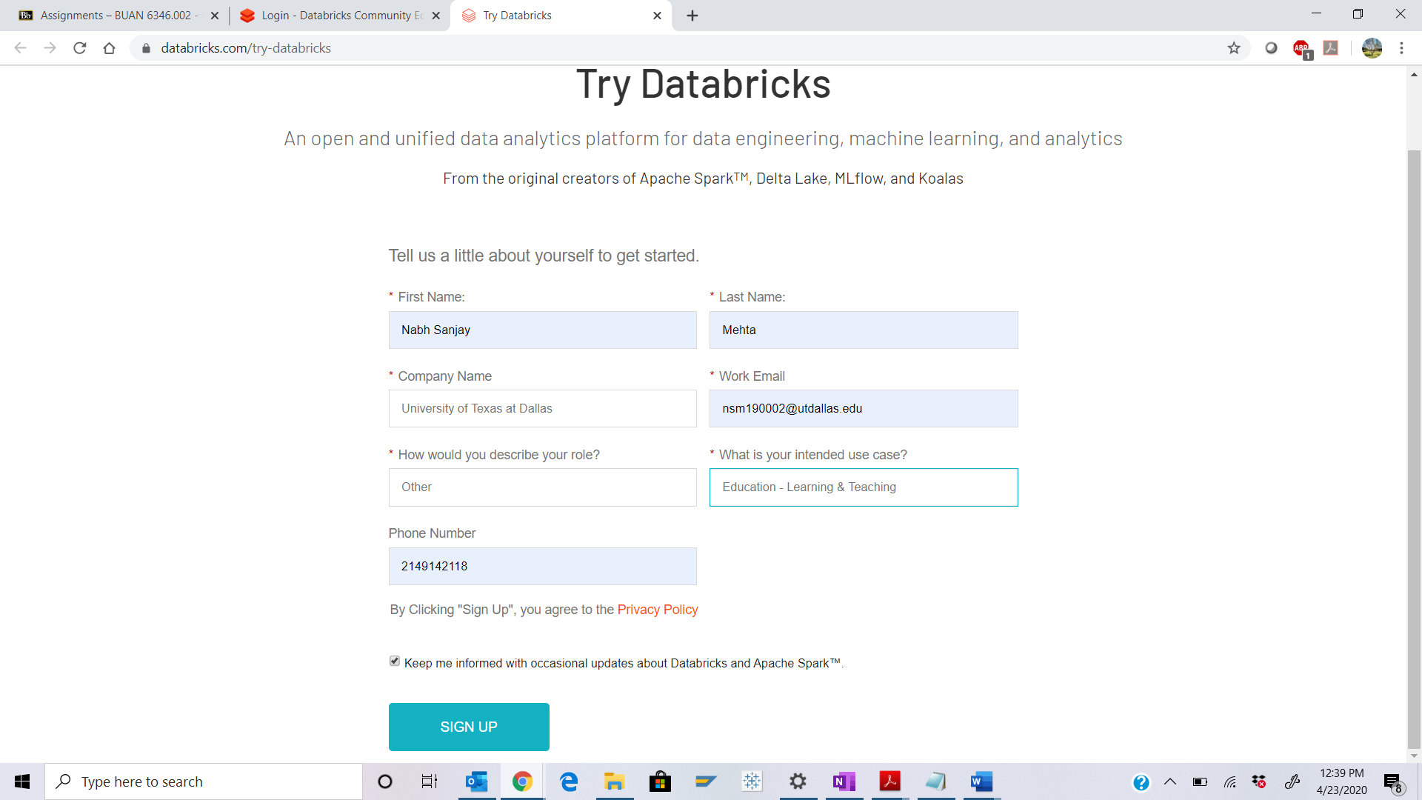

Step 2: Verify and confirm the databricks account from the email you have received from Databricks.

Go to the link again and click on “Sign In”.

Q. Login to your databricks account and take a screenshot of the Home page output and paste it below.

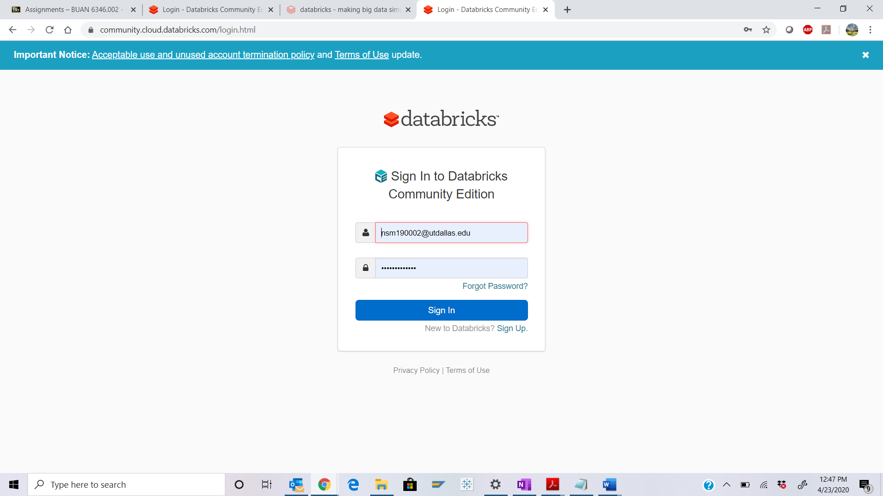

Part 2: Create a cluster node.

Step 3: Click on the “Clusters” icon as shown in the screenshot below:

`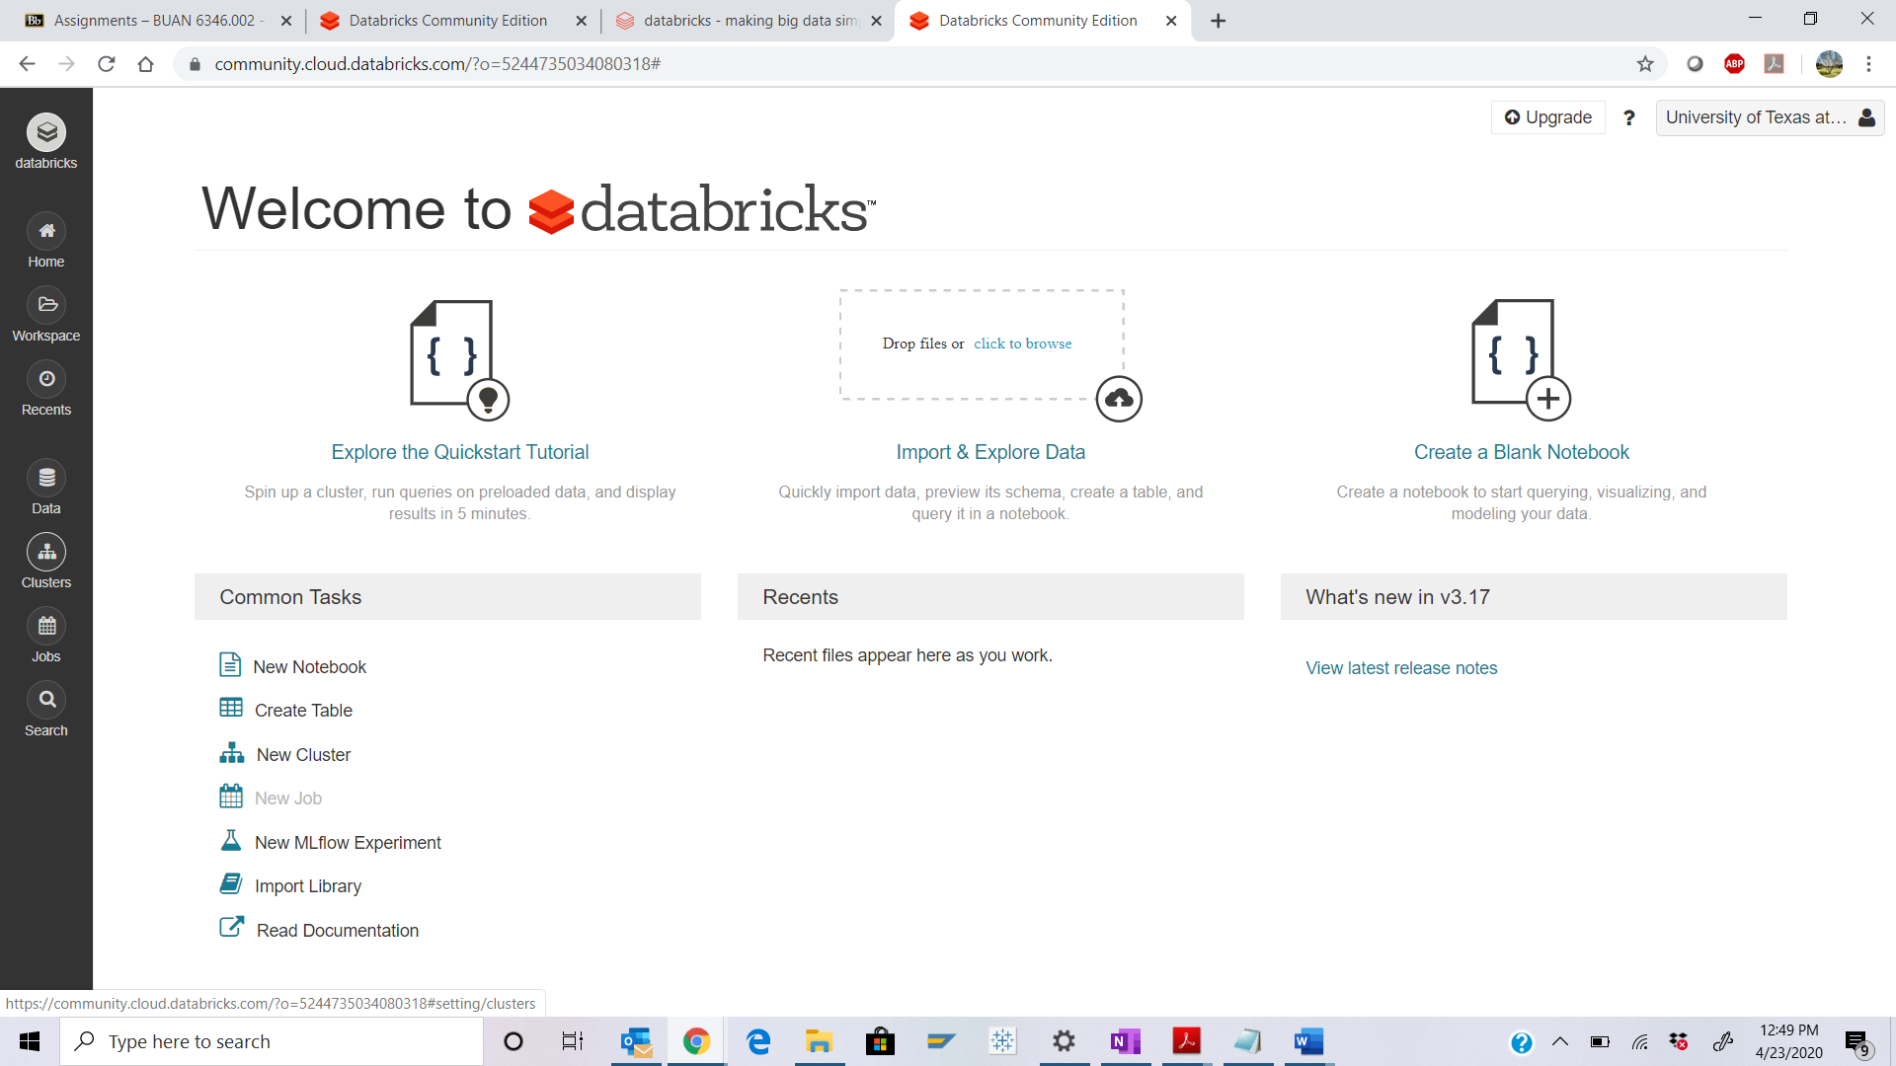 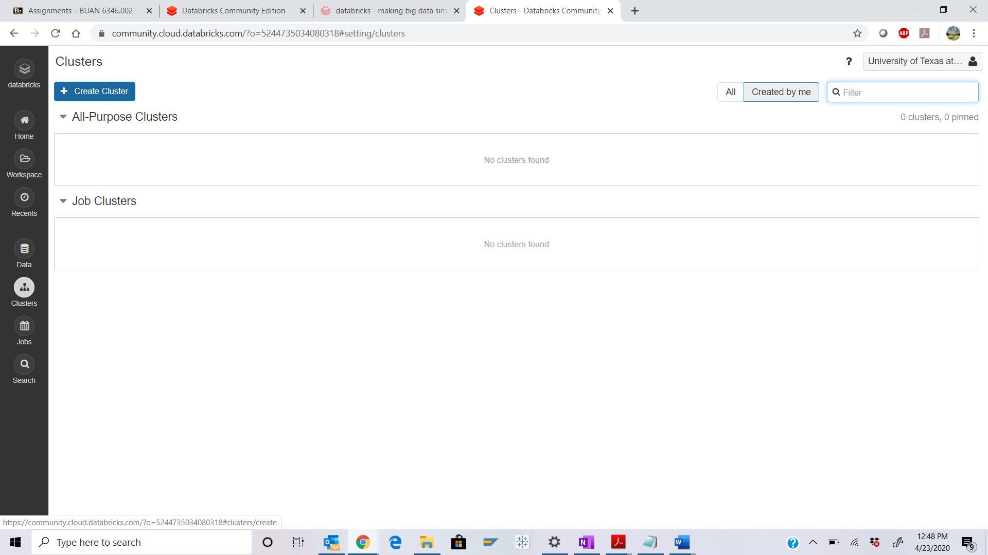 Step 4: Name the cluster as “FirstName_LastName_CaseStudy”.



Q. Take a screenshot of the Create Cluster page and paste it below.

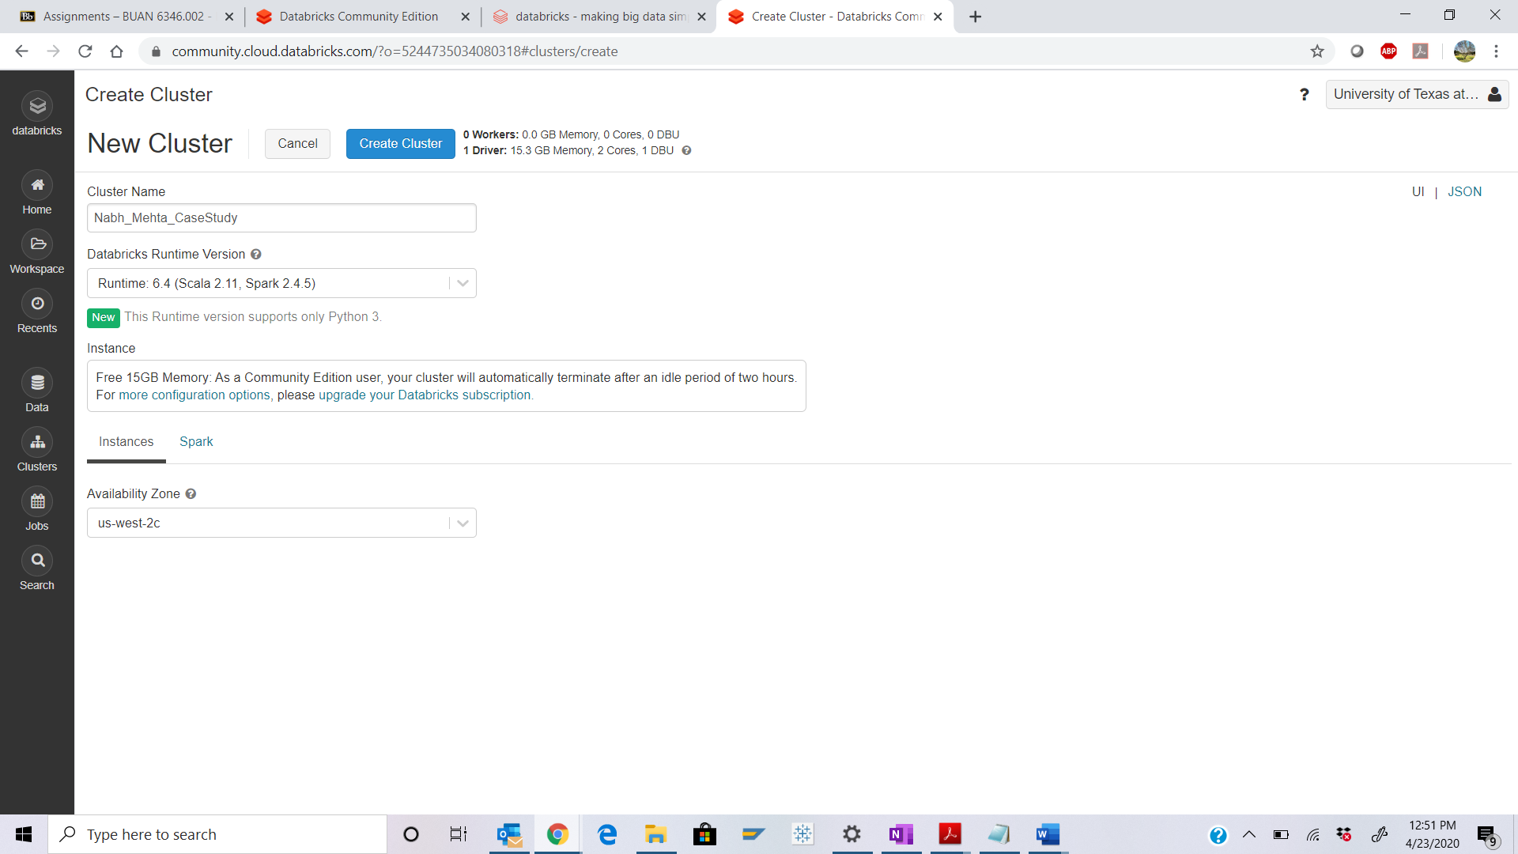

Step 5: Green sign shows that a cluster is created and running successfully.

Q. Take a screenshot of the running Cluster Page and paste it below.

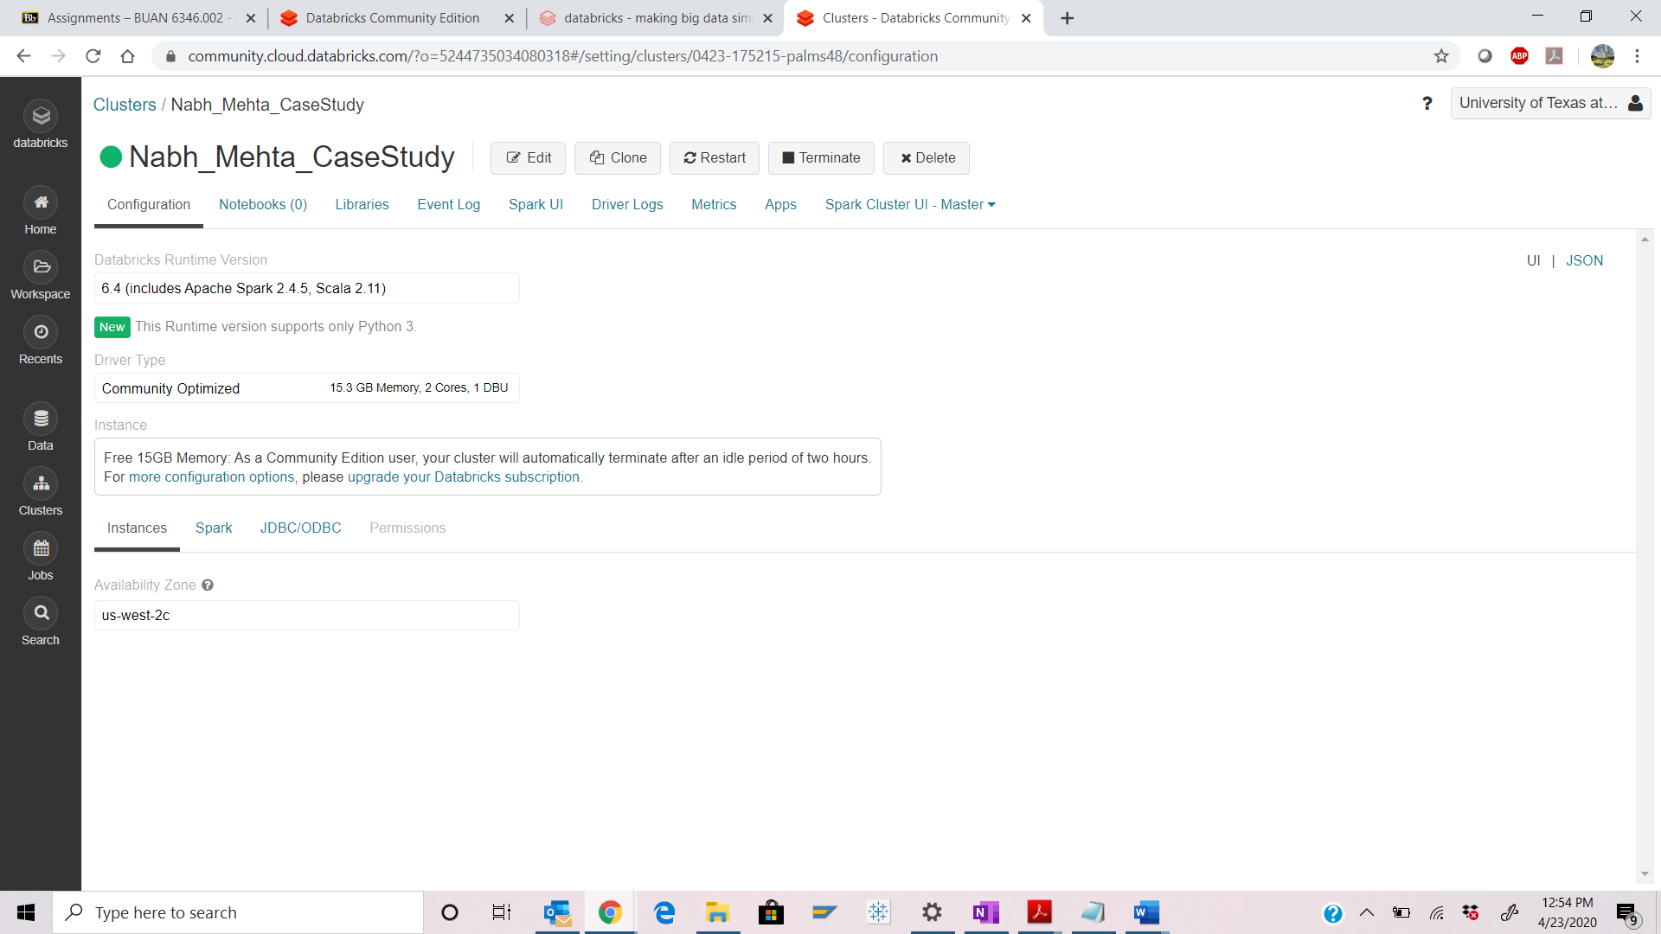 Part 3: Create Datatable.

Step 6: Download the “Bank.csv” file from eLearning.

Select the “Data” icon from the left panel and click on “Add Data”.

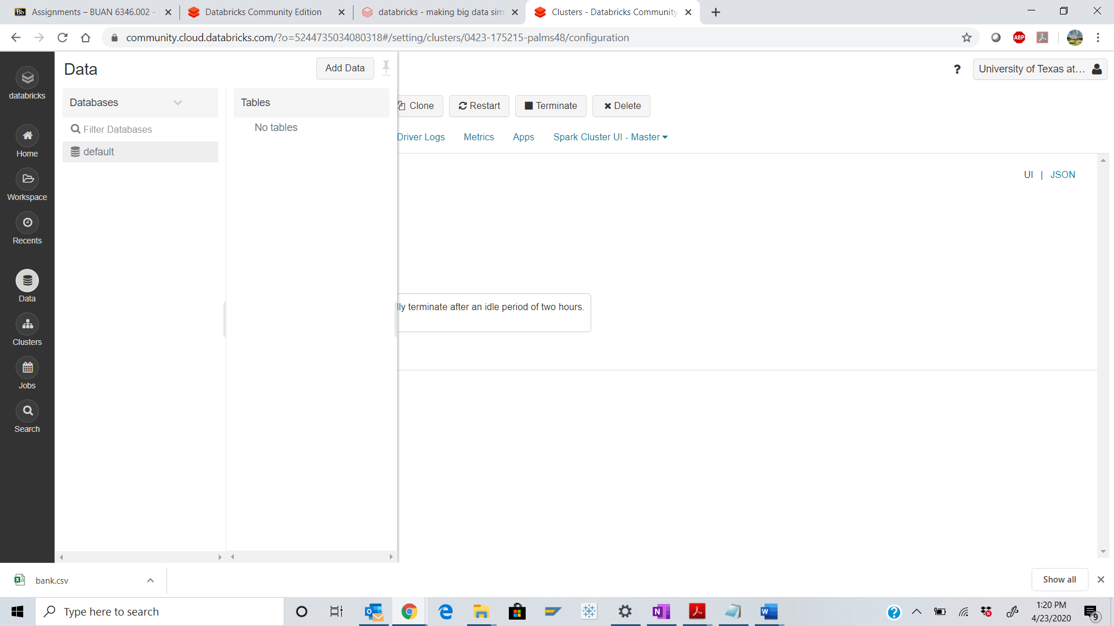

Step 7: Click on browse and select the “bank.csv” file that you downloaded from eLearning.

Take a screenshot of the uploaded file and paste it below.

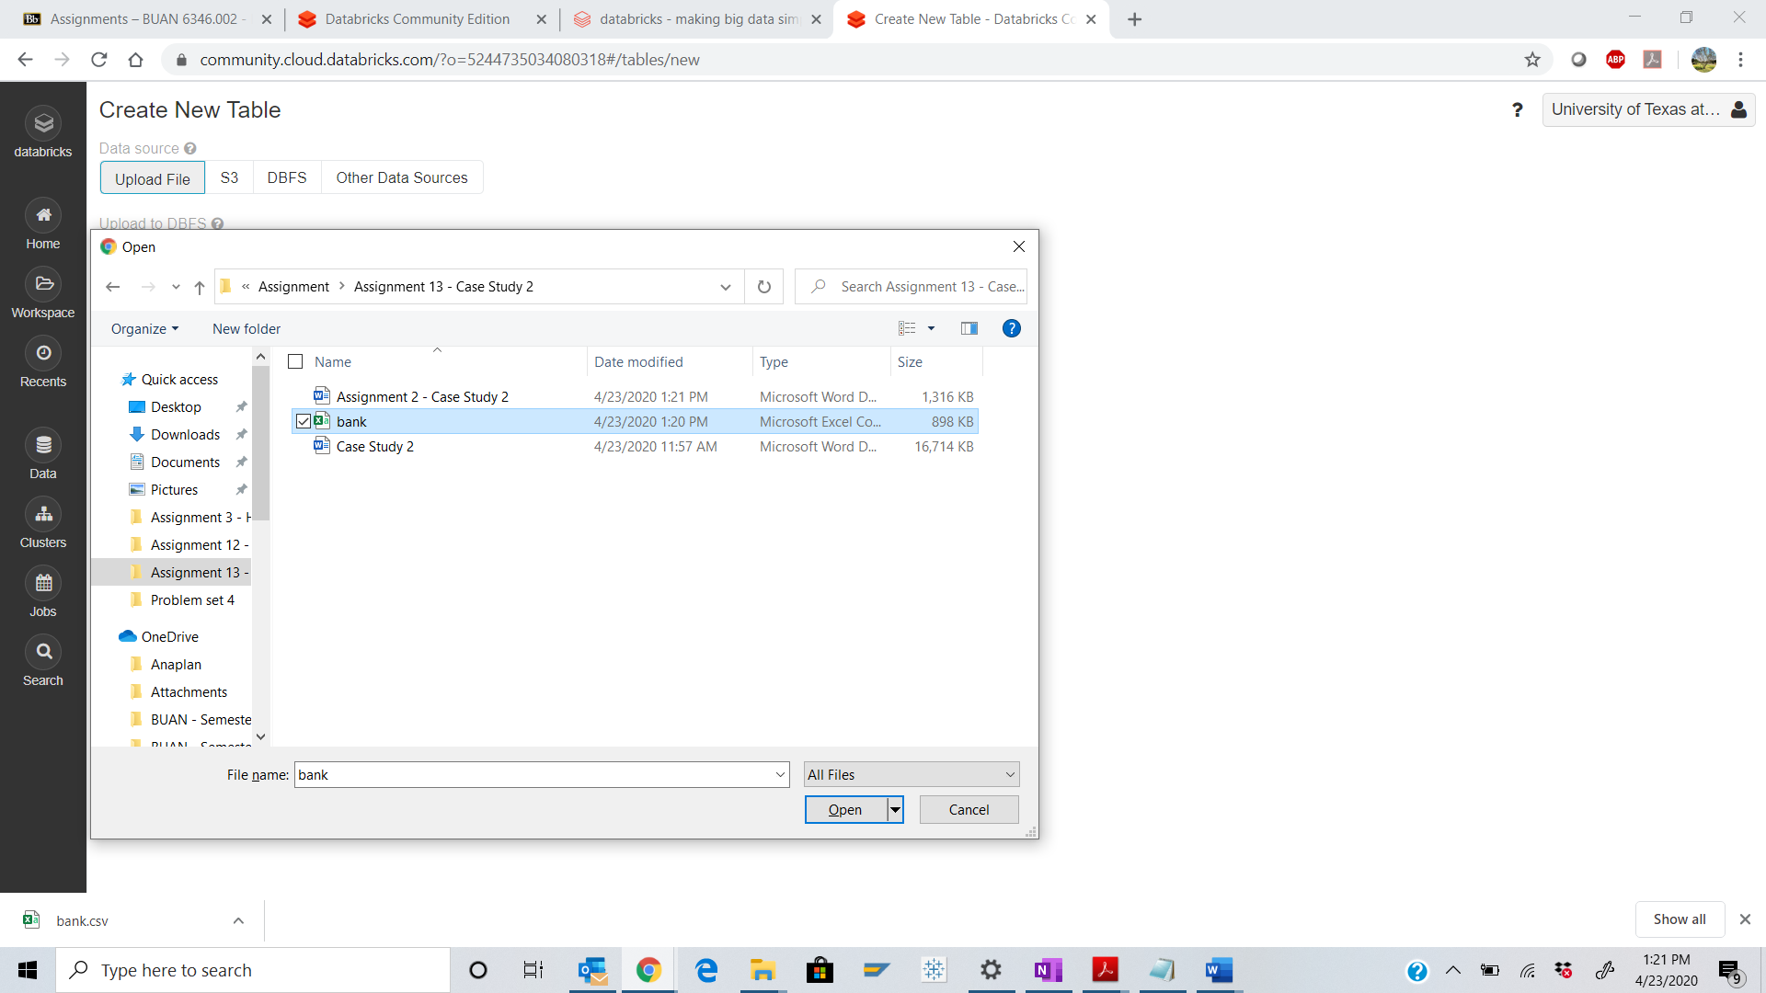 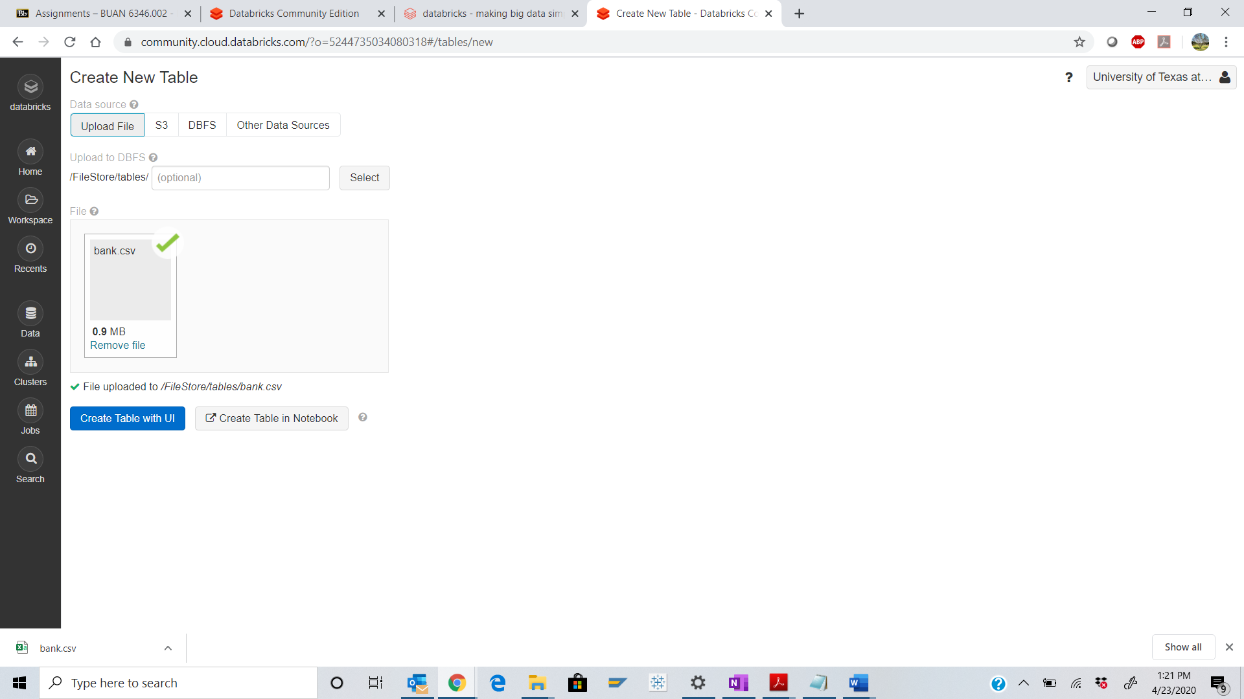 Step 9: The file location can now be seen.

Q. Take a screenshot of the table created and paste it below.

Copy the file location and paste it here.

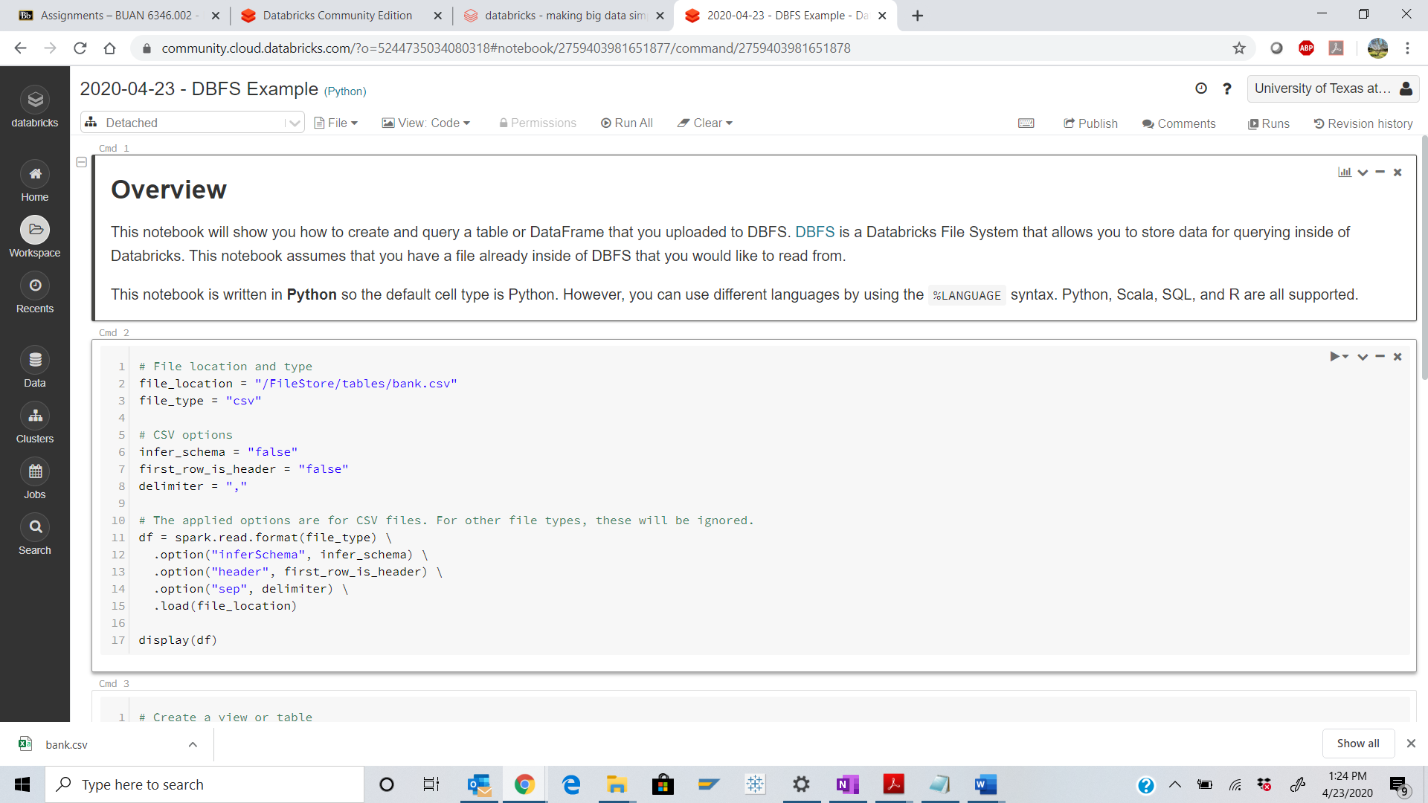 Part 4 : DataFrame Operations.

Step 10: Create new Notebook. Follow the steps below.

Click on “Databricks”. 

Click on “New Notebook”.

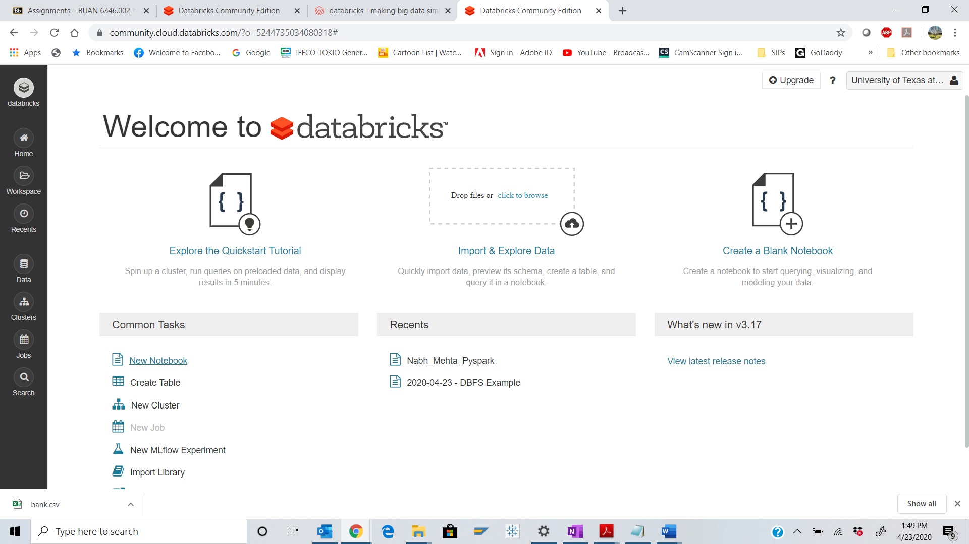

Step 11: Create the notebook with “FirstName_LastName_Pyspark”.

Language: “Python”

Cluster: Select the cluster we have created in part 1.

Q. Take a screenshot of the blank notebook and paste it below.

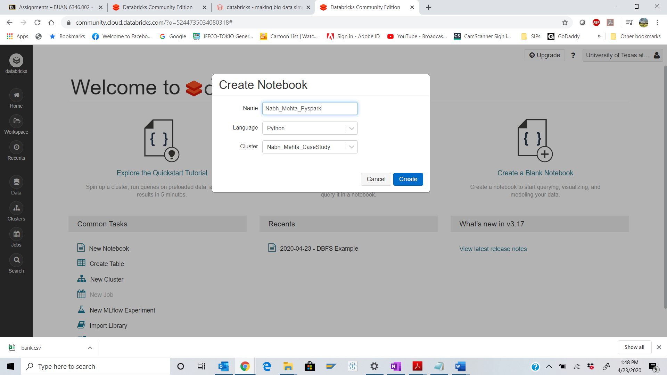 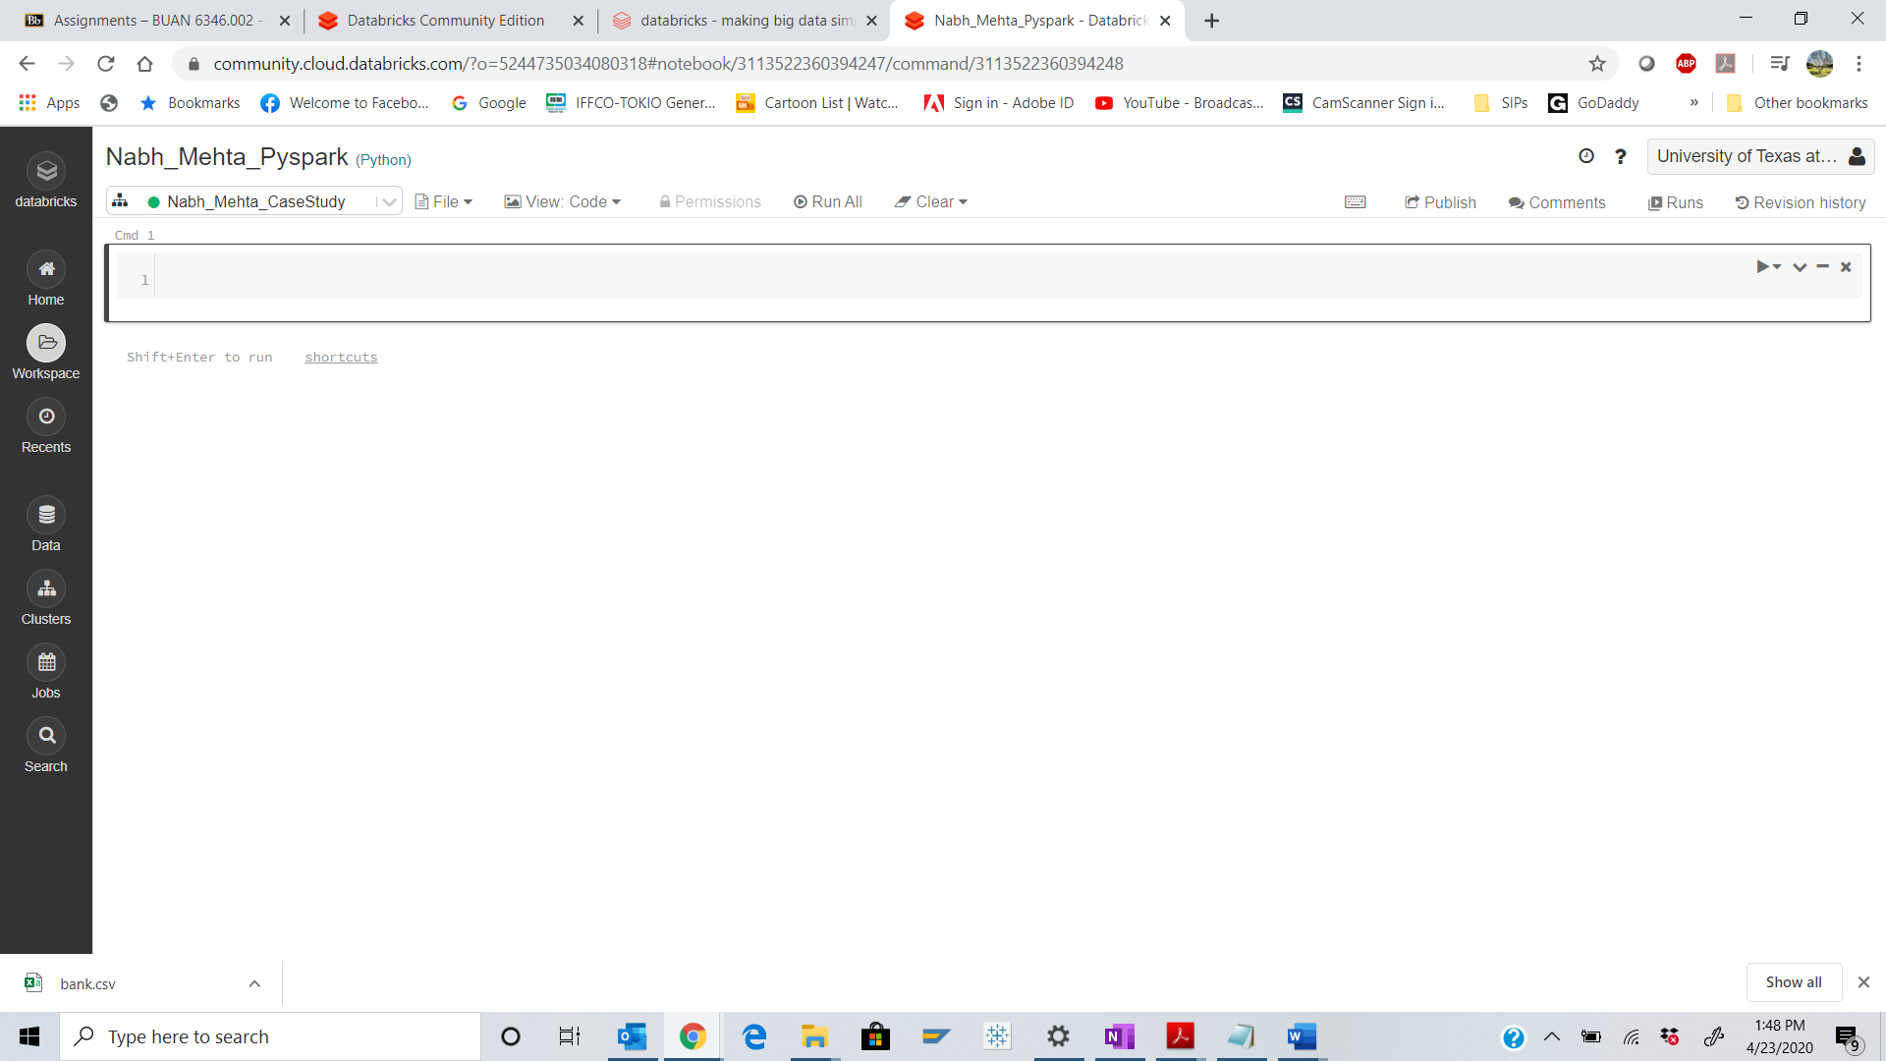

Step 11: Import the required libraries from Spark.

Q. Take a screenshot of the output of the code and paste it below.

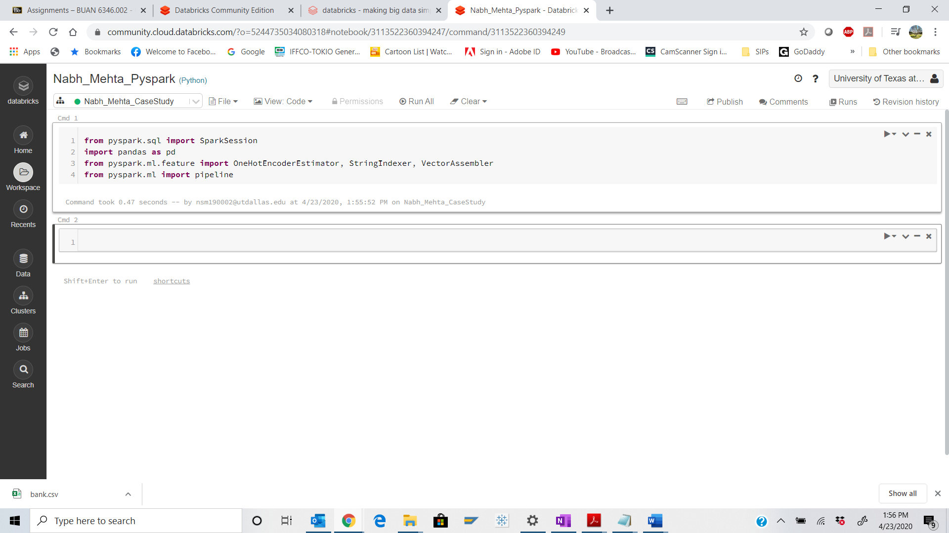

Step 12:

Click on “+” sign at the end of the cell.

Type the code found below:

(Replace the path with your path that you copied in step 9)

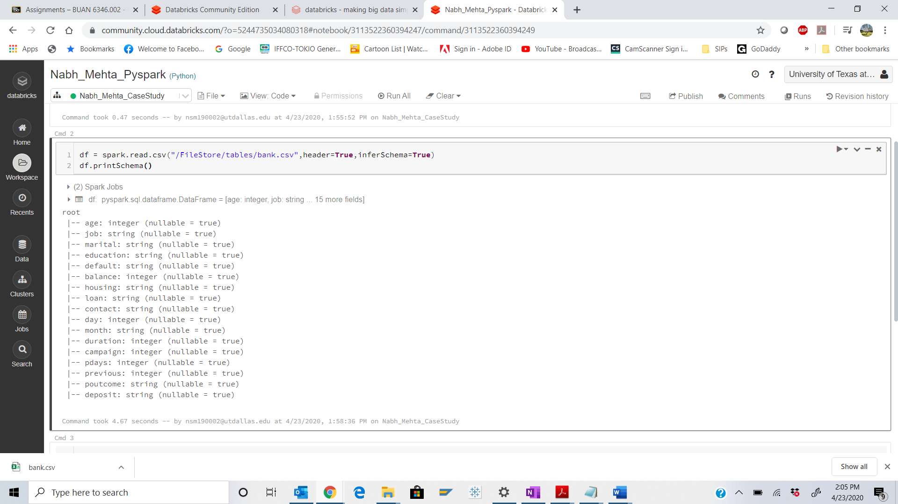

Step 13: Type the code below in the next cell and Run the cell.

Q. Take a screenshot of the output of the code and paste it below.

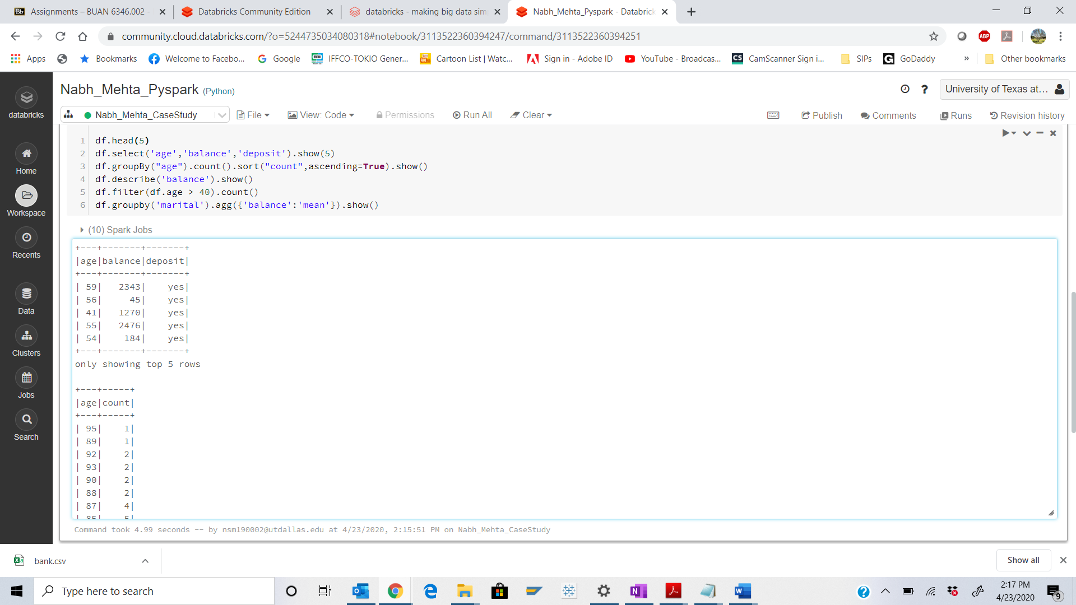

i. Describe “Select”, “Group by” operations in one line.

Ans: Select statement here will run the query for 3 fields age/balance/deposit and fetch 5 rows. GroupBy will categorize the output for count of age.

ii. How many customers are there with an age greater than 40?

Ans: 4967

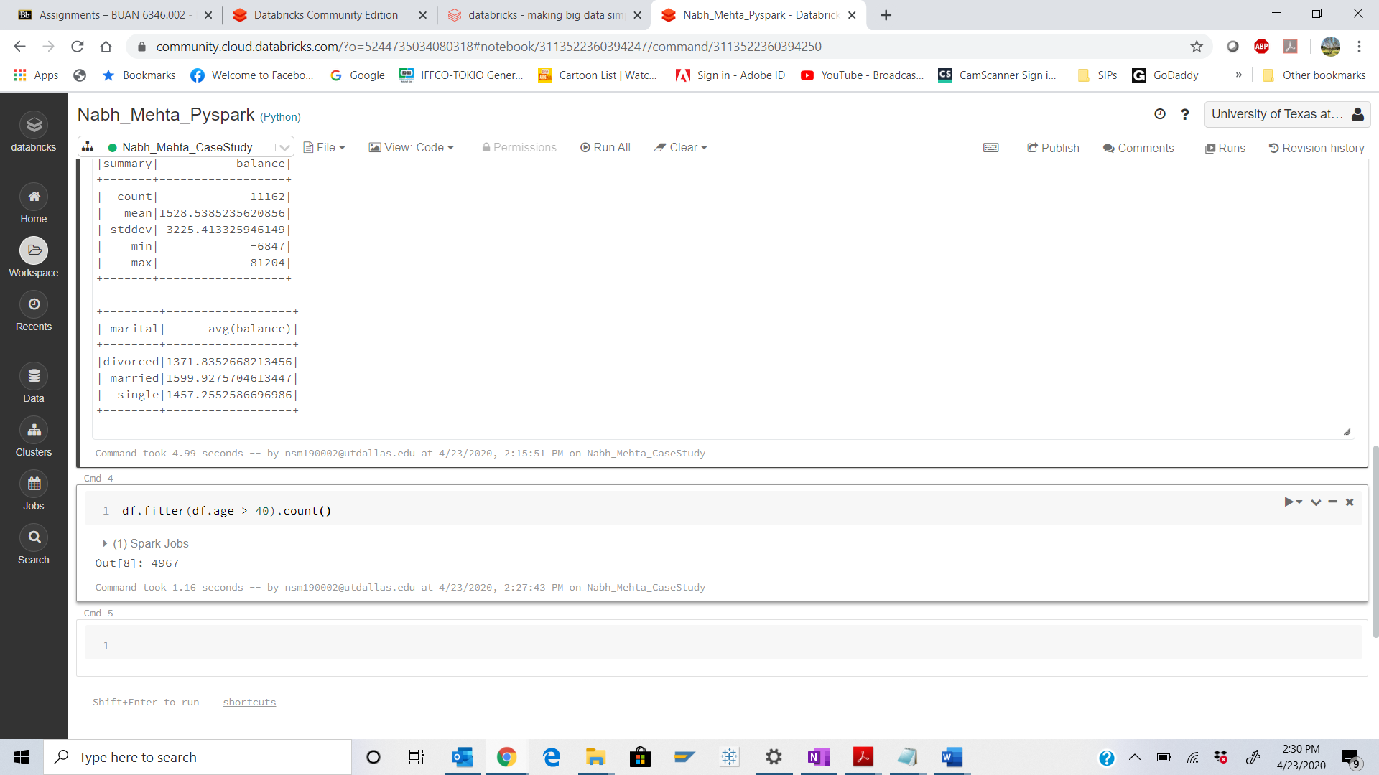

iii. Why are there only 5 records viewable?

Ans: because we are using the command ‘.show(5)’ and ‘.head(5)’ to explicitly display 5 records only

Step 14: Execute the following code:

Q. Take a screenshot of the output of the code and paste it below.

What is seen in the output of the transpose?

Ans: Rows are transposed to columns

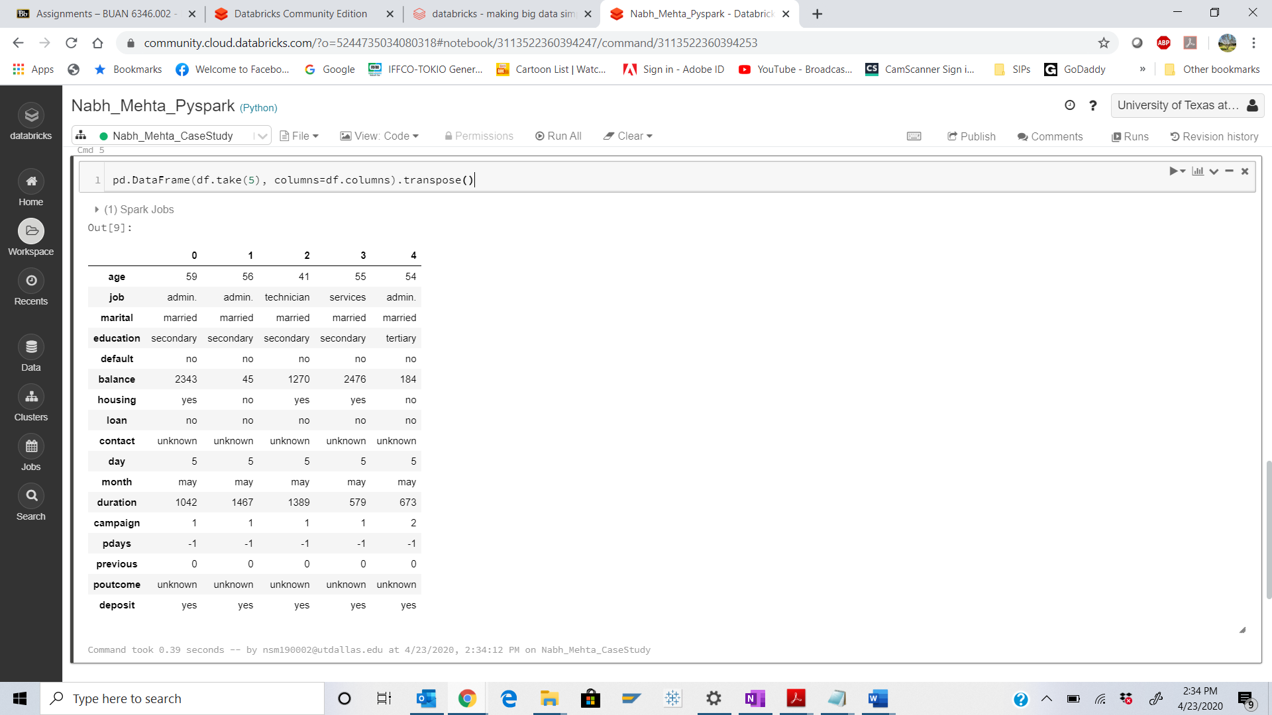

Step 15: Execute the following code:

Q. Take a screenshot of the output of the code and paste it below.

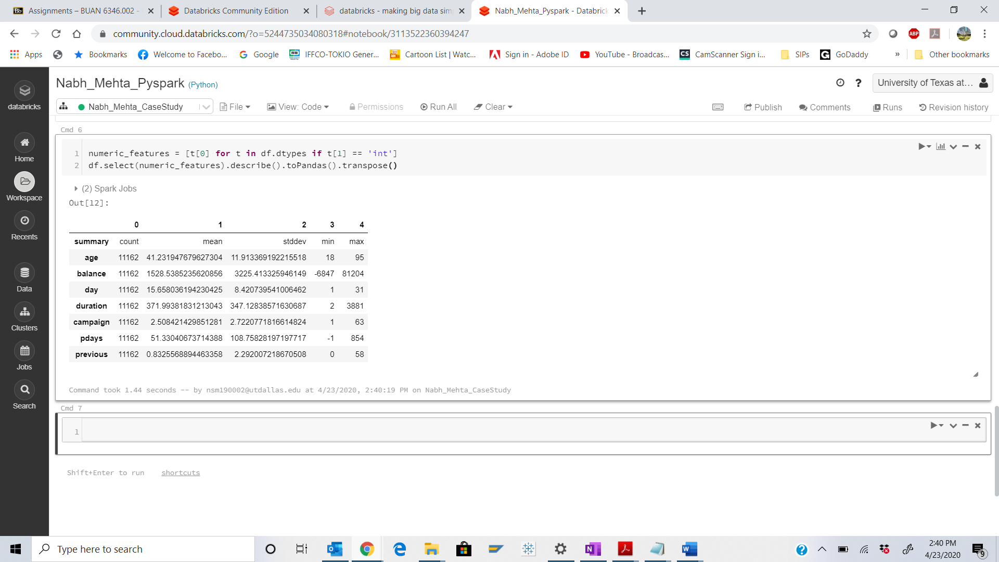

Part 5: Data Preprocessing:

Step 16: Execute the following code:

Q. Take a screenshot of the output of the code and paste it below.

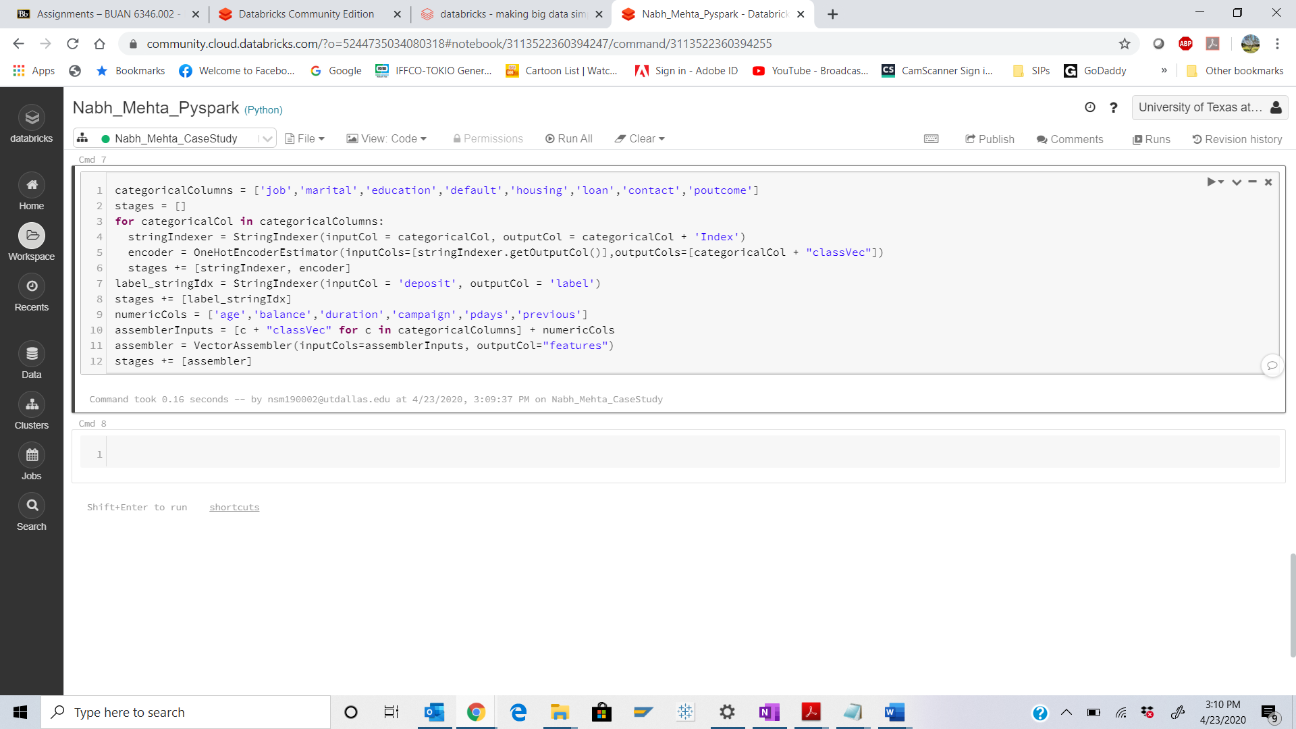

Step 17: Execute the following code:

Q. Take a screenshot of the output of the code and paste it below.

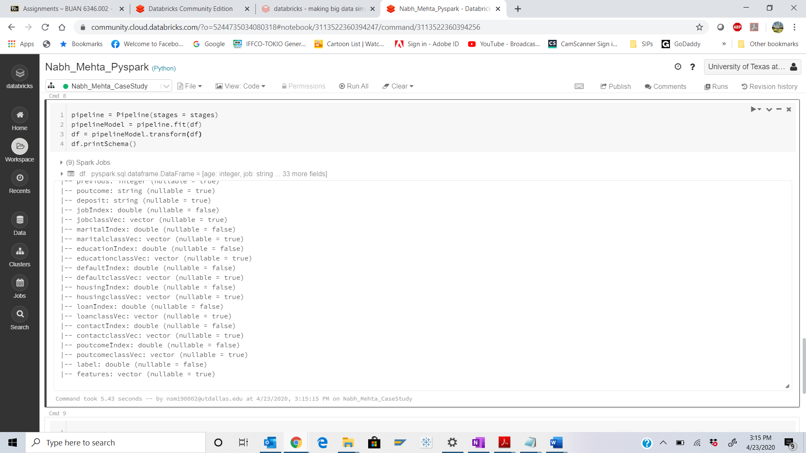

Step 18: Execute the following command:

Q. Take a screenshot of the output of the code and paste it below.

Define the purpose of the transpose function?

Ans: The transpose() function is used to transpose index and columns. Reflect the DataFrame over its main diagonal by writing rows as columns and vice-versa. It is mainly used for data analysis.

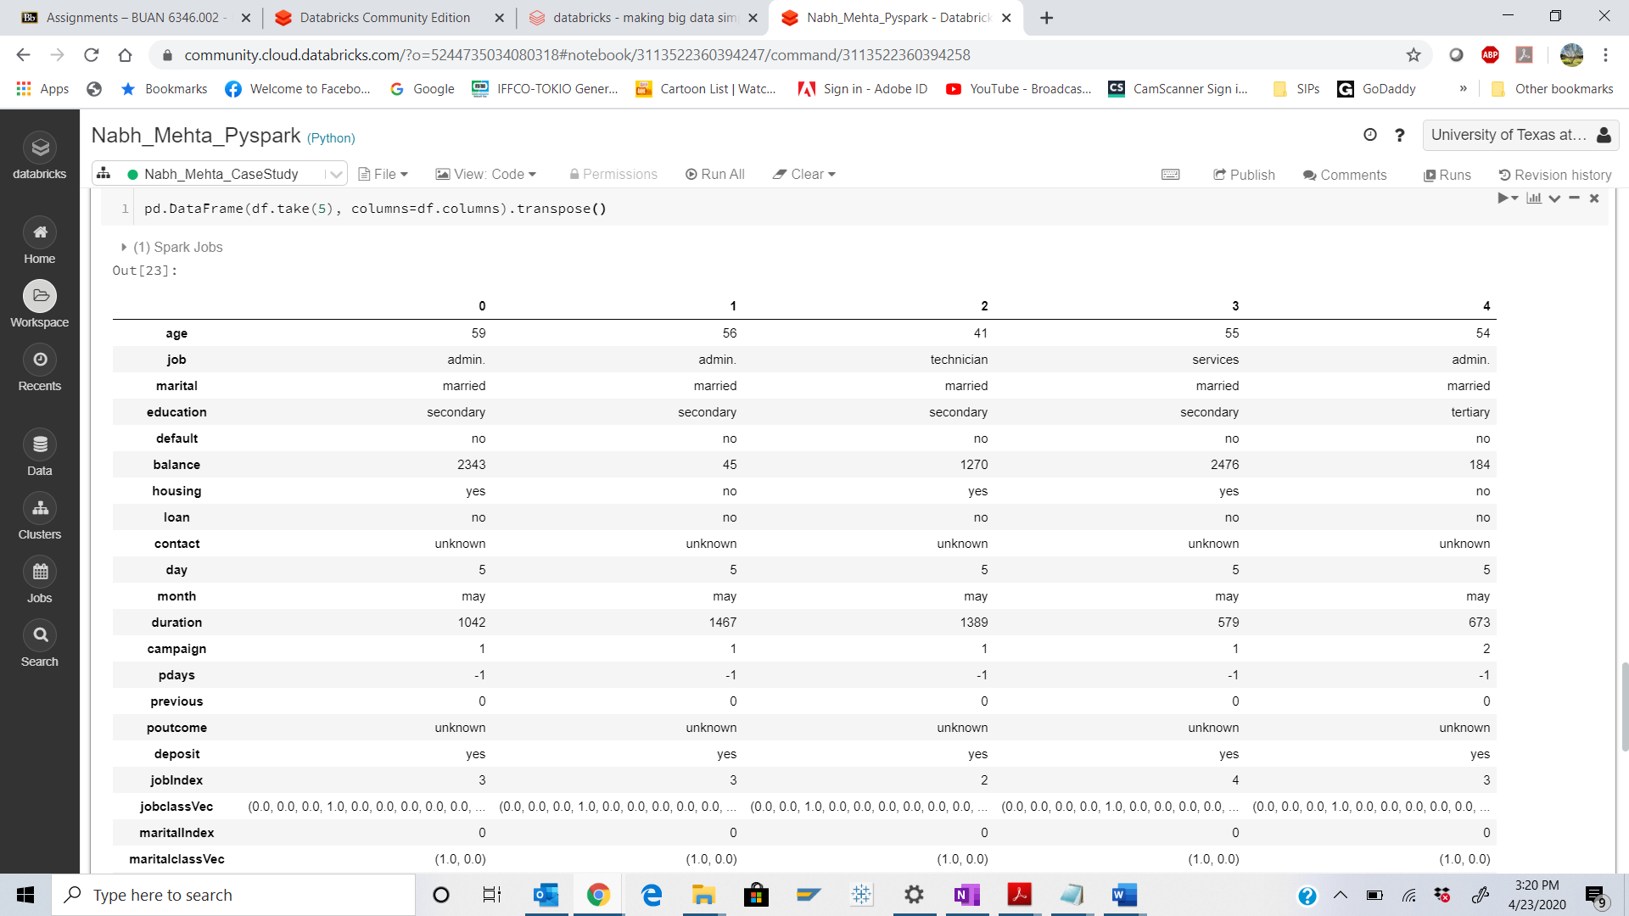

Step 19: Execute the following code:

Q. Take a screenshot of the output of the code and paste it below.

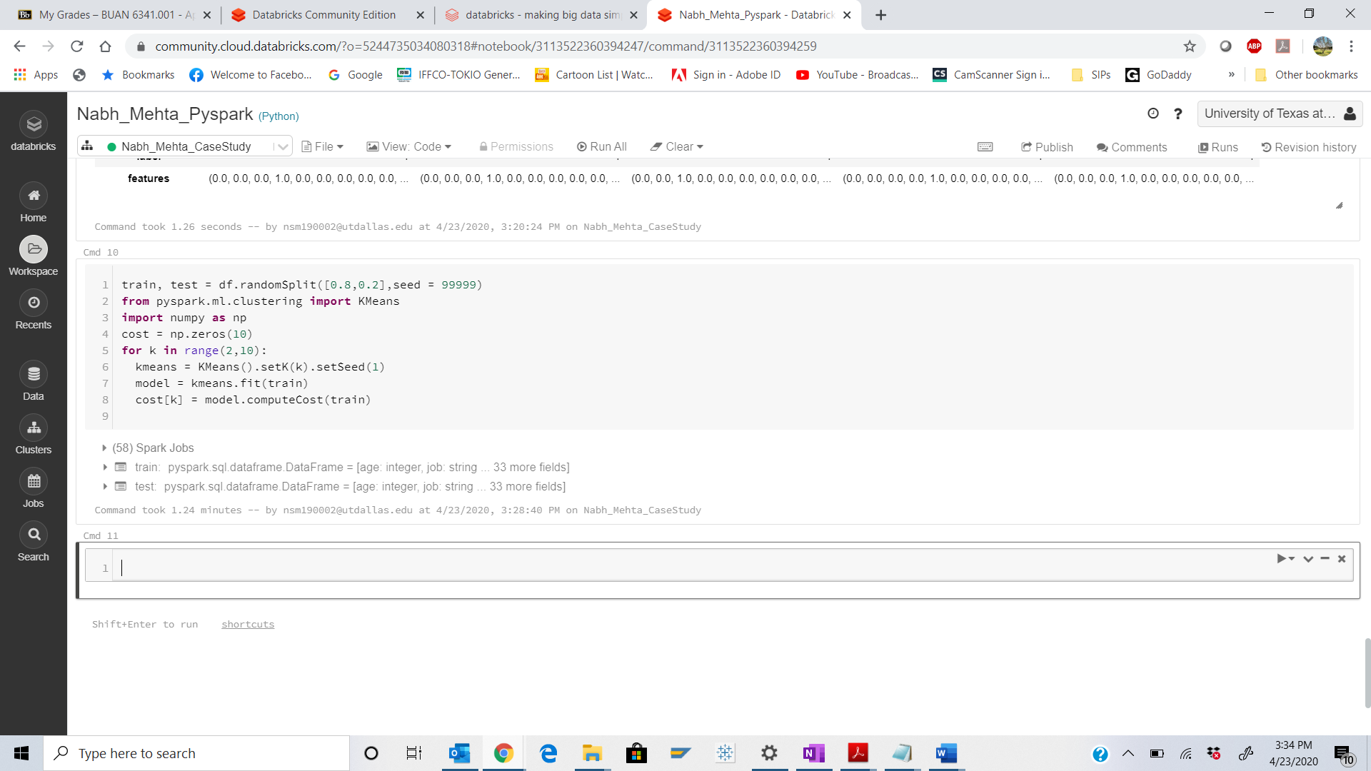

Step 20: Execute the following code:

Q. Take a screenshot of the output of the code and paste it below.

Comment about the graph that is plotted here.

Ans: I can see a elbow(steep curve) at K=4 and flattening after k=5. We can choose K=4

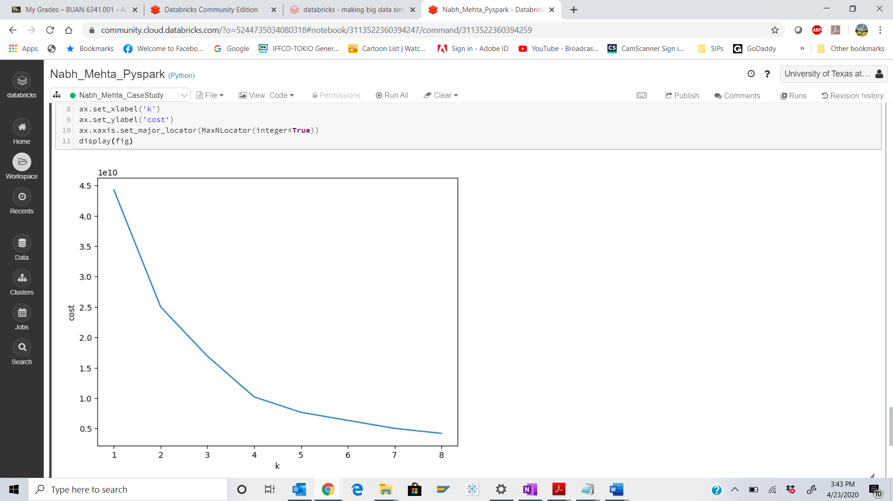

Step 21: Execute the following code:

Q. Take a screenshot of the output of the code and paste it below.

The code below shows implementation of K means for 8 Clusters. As you will see, this model performs poorly with 8 clusters. We want to improve our model. Refer to the graph and implement the code below testing different numbers of clusters (for example cluster number = 3,4,5 etc.) to find the best model.

Refer to Step 21 and step 22 for the training dataset.

Refer to Step 24 and Step 25 for the testing dataset.

Show output of each cluster scenario that you evaluated.

**Best Model evaluated after step 25 in this document**

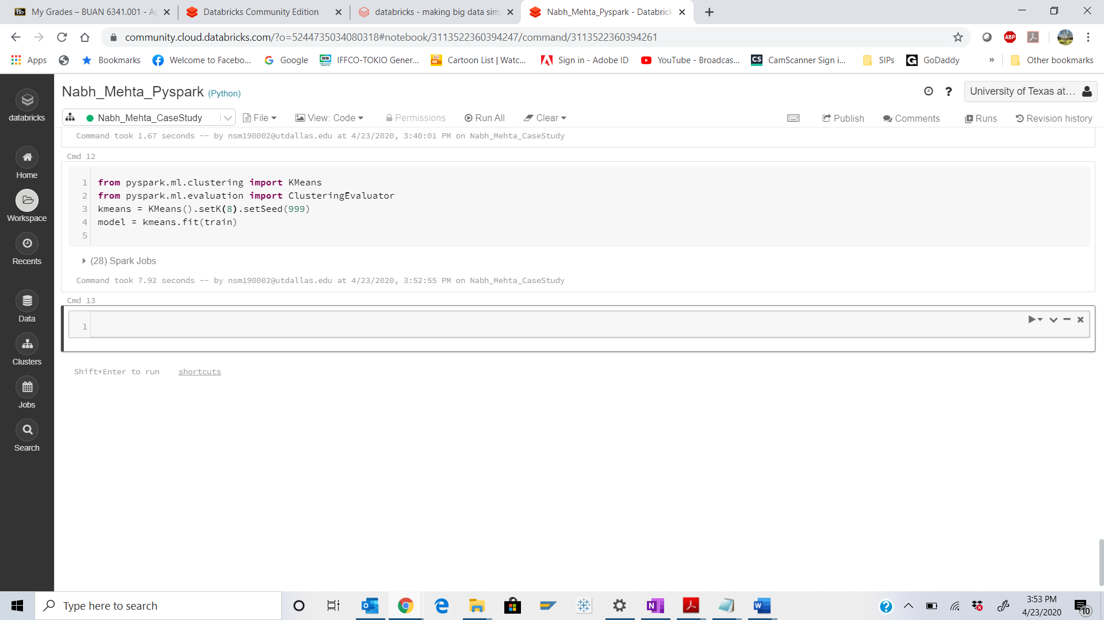

Step 22: Execute the following code:

Q. Take a screenshot of the output of the code and paste it below.

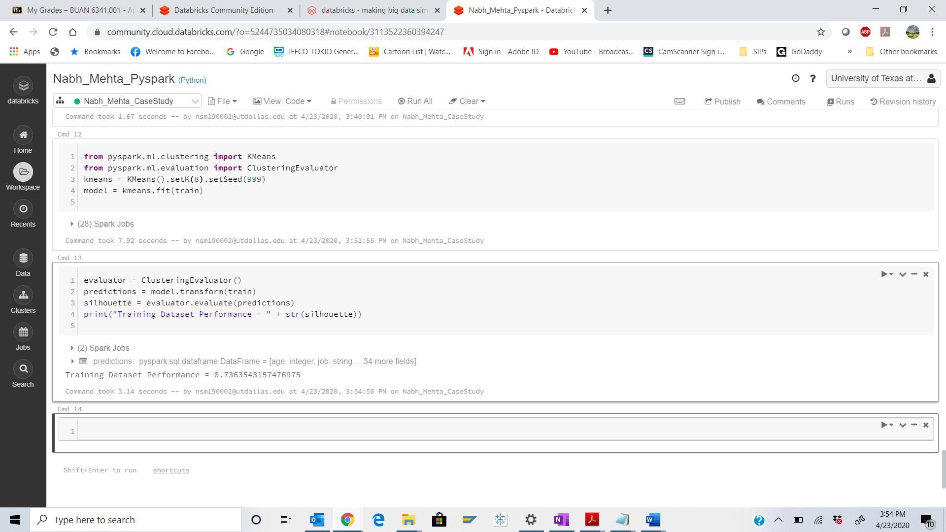

Step 23: Execute the following code:

Q. Take a screenshot of the output of the code and paste it below.

What is Centroid and how is it calculated in K-means?

Ans: Centroid is an imaginary data point at the center of the cluster.

1. Each centroid is an existing data point in the given input data set, picked at random, such that all centroids are unique (that is, for all centroids ci and cj, ci ≠ cj).
2. These centroids are used to train a kNN classifier. The resulting classifier is used to classify (using k = 1) the data and thereby produce an initial randomized set of clusters. Each centroid is thereafter set to the arithmetic mean of the cluster it defines.
3. The process of classification and centroid adjustment is repeated until the values of the centroids stabilize.
4. The final centroids will be used to produce the final classification/clustering of the input data, effectively turning the set of initially anonymous data points into a set of data points, each with a class identity.

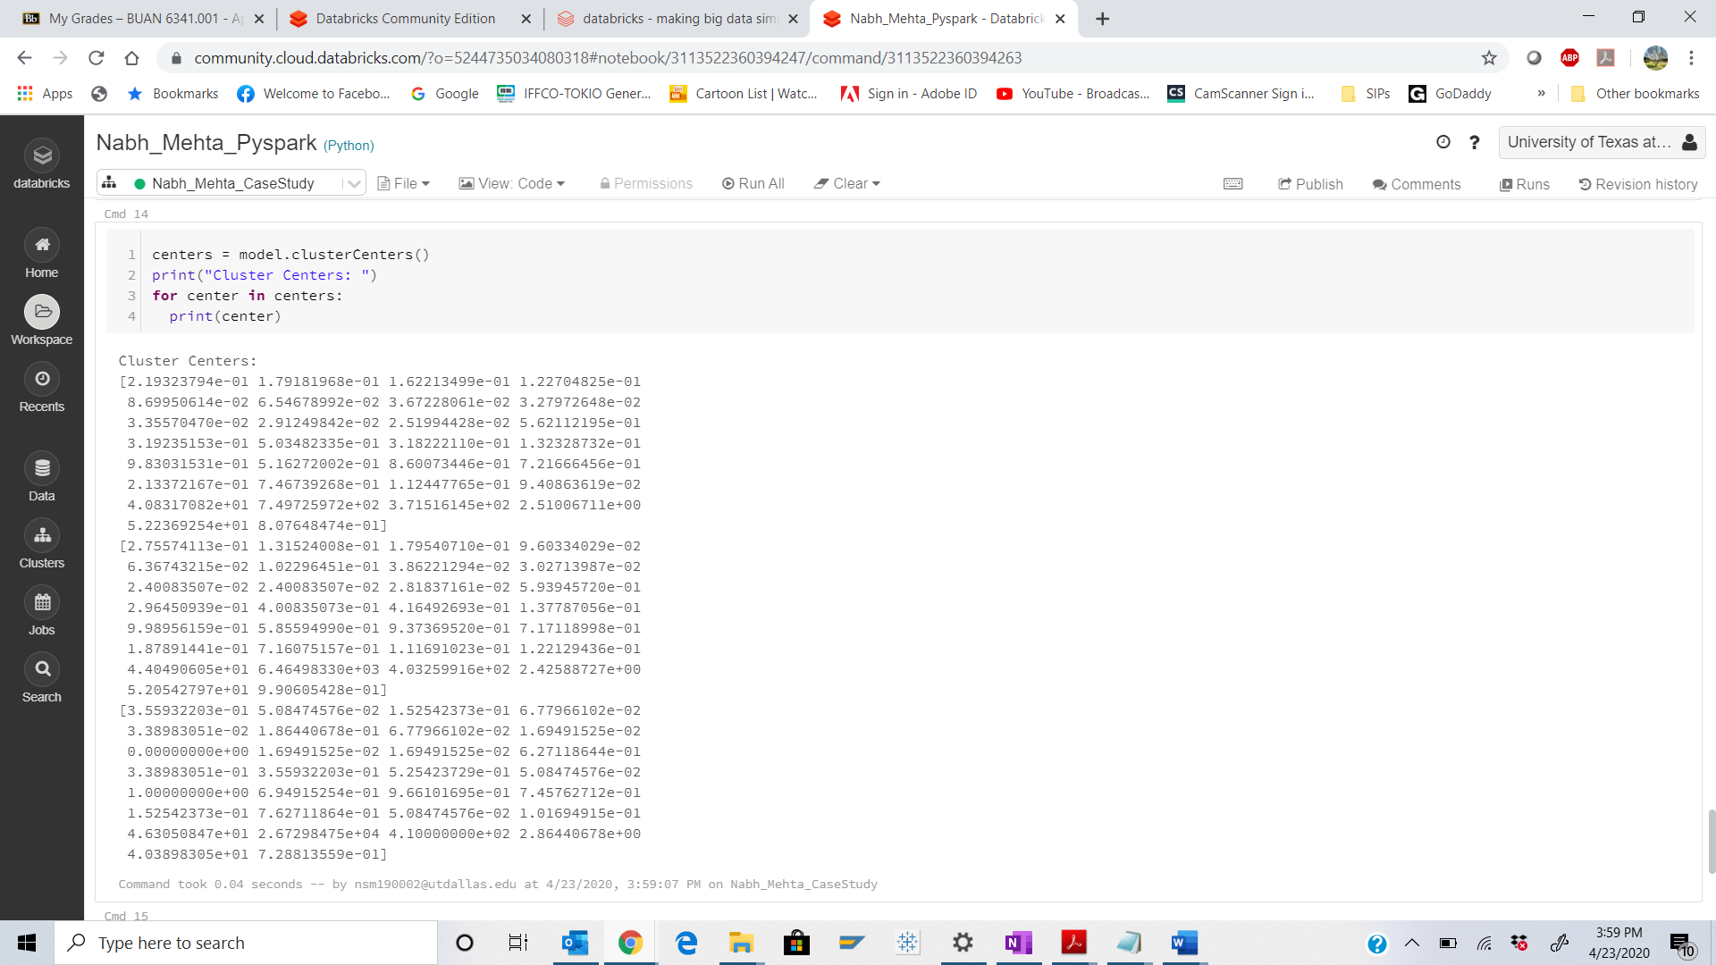

Step 24:

Execute the following code:

Q. Take a screenshot of the output of the code and paste it below.

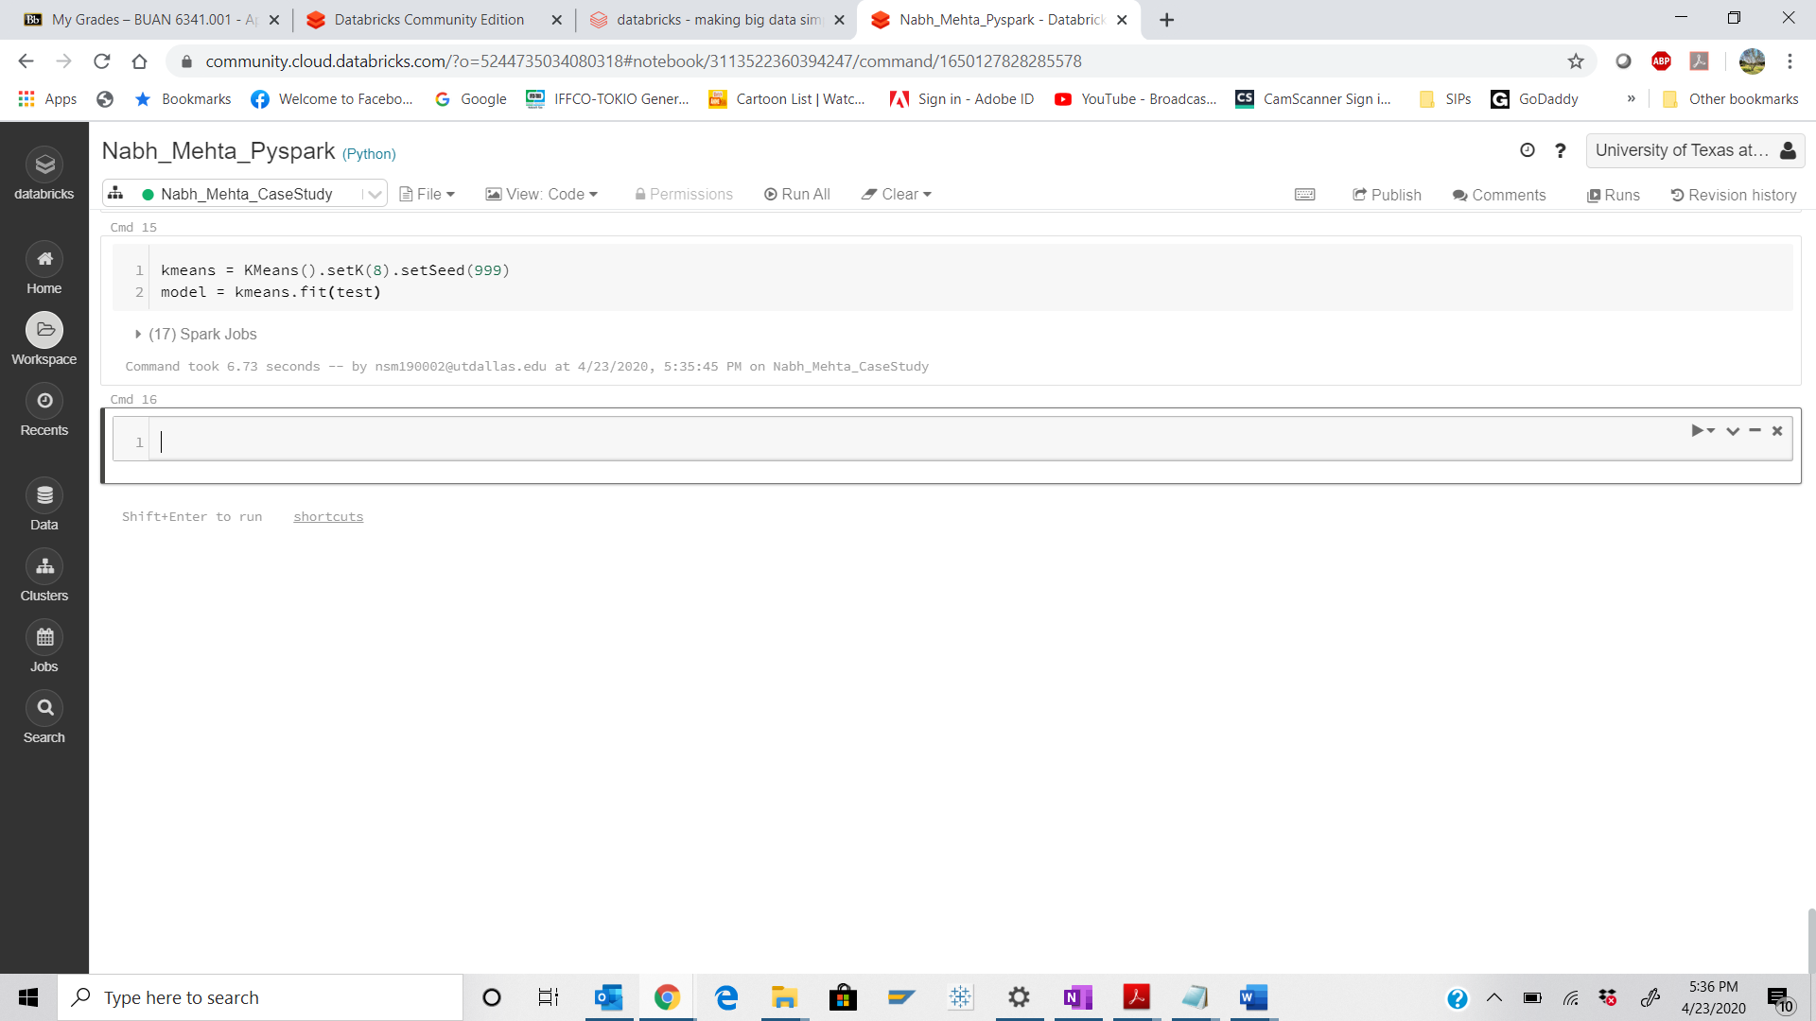

Step 25: Execute the following code:

Q. Take a screenshot of the output of the code and paste it below.

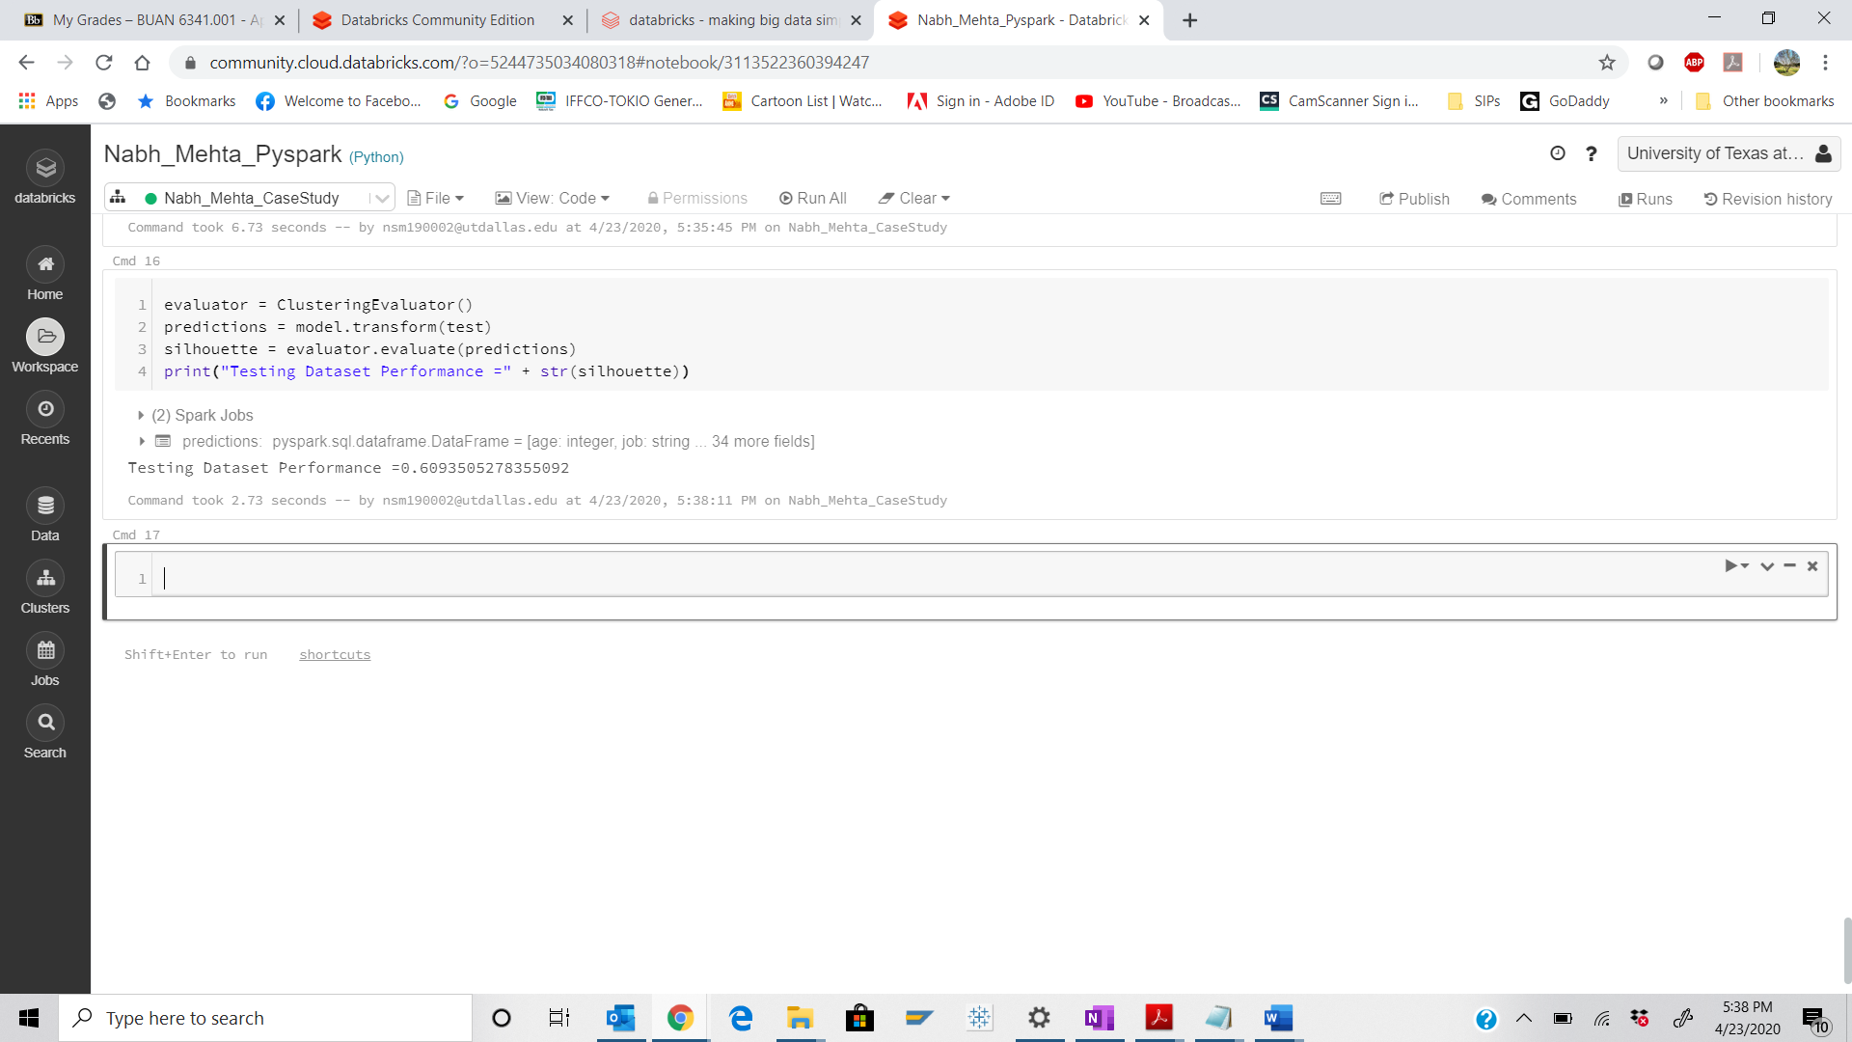

**Best Model evaluation: K=3**

1. **K = 3**
2. **Training Dataset Performance = 0.879399553497968**
3. **Testing Dataset Performance =0.8752390670209059**

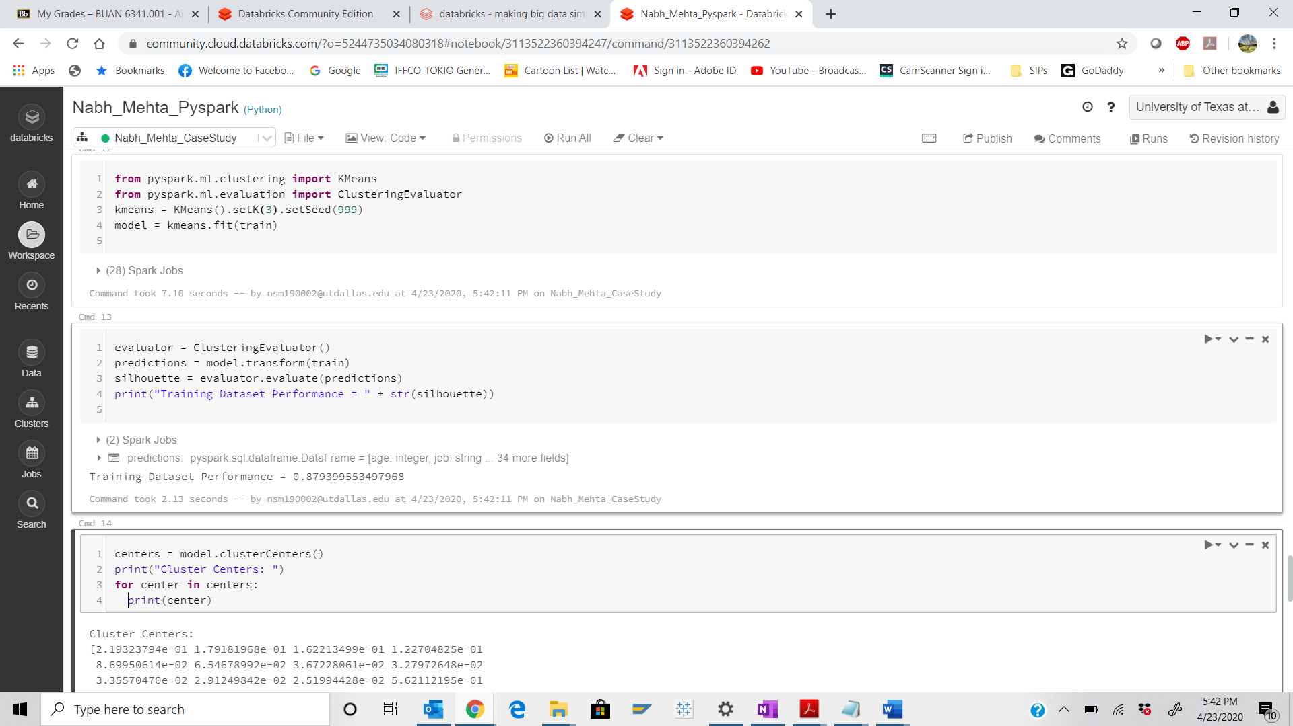

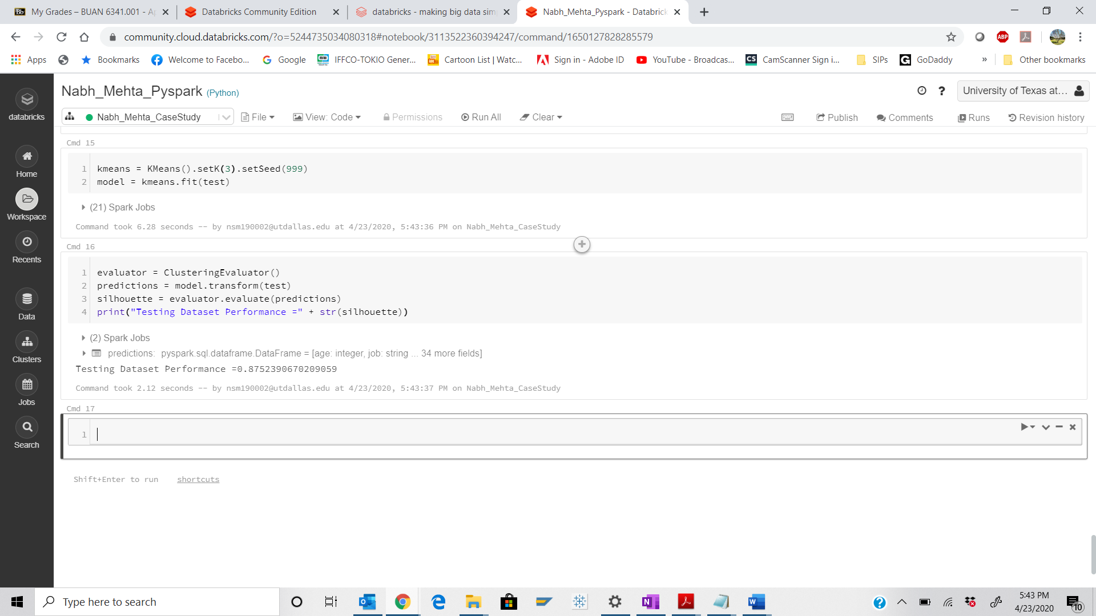

1. **K = 4**
2. **Testing Dataset Performance =0.8752390670209059**
3. **Testing Dataset Performance =0.8727179706813601**

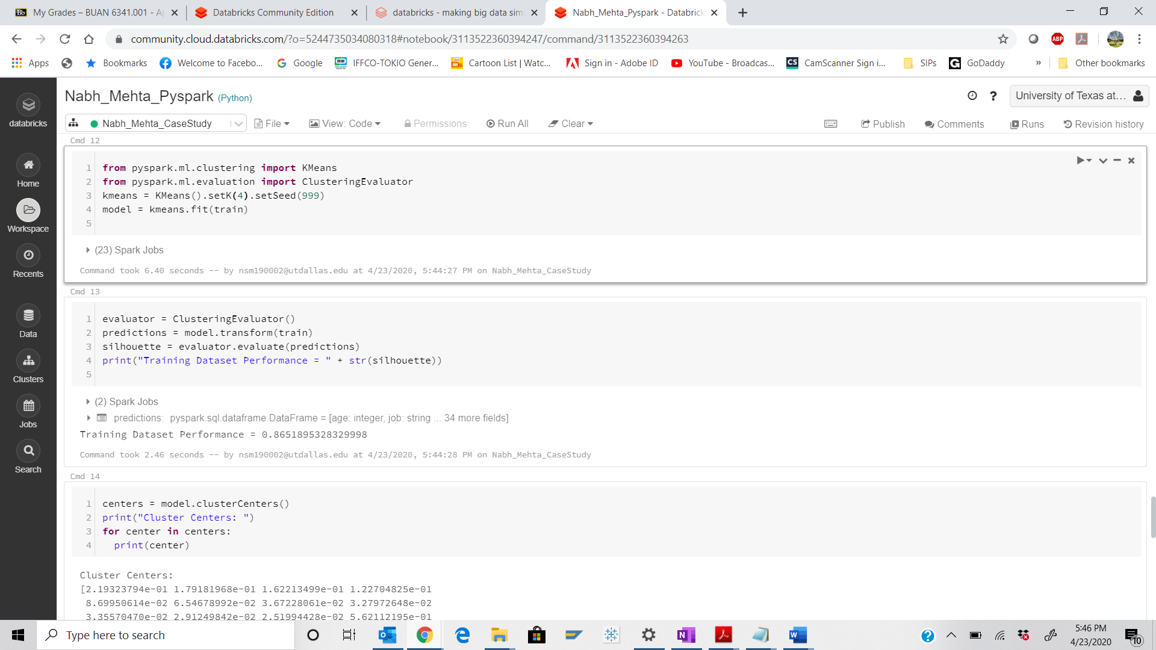

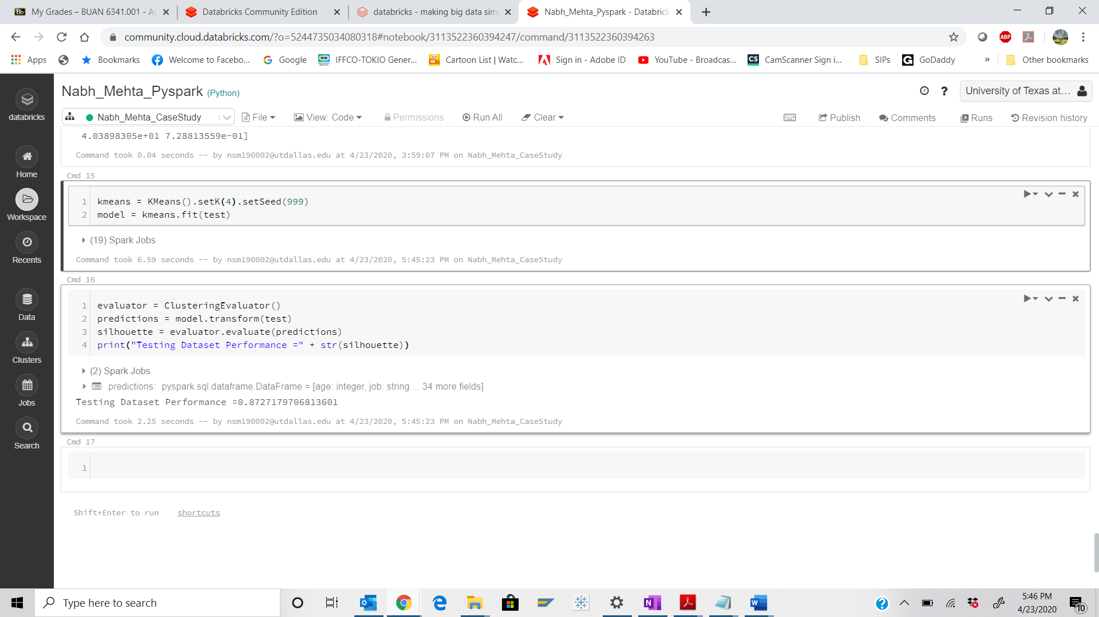

1. **K = 5**
2. **Training Dataset Performance = 0.8208494545136753**
3. **Testing Dataset Performance =0.872179120621171**

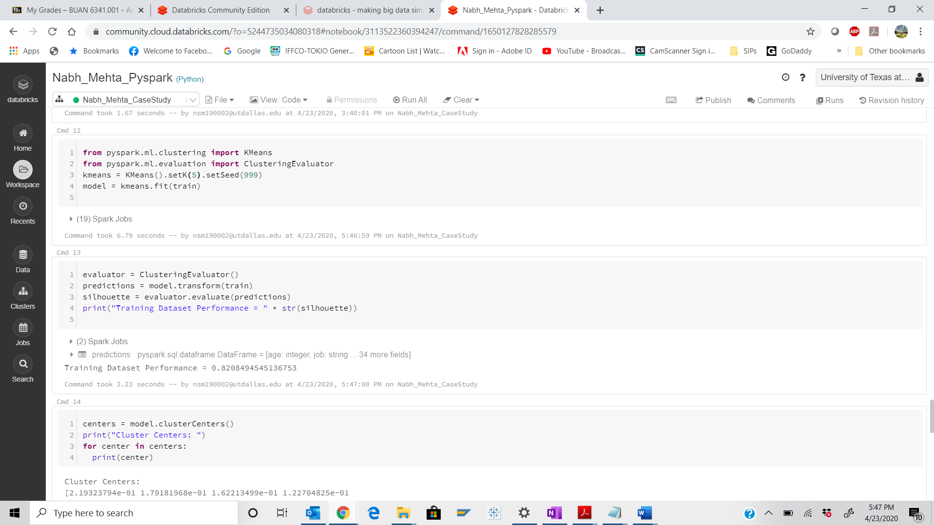

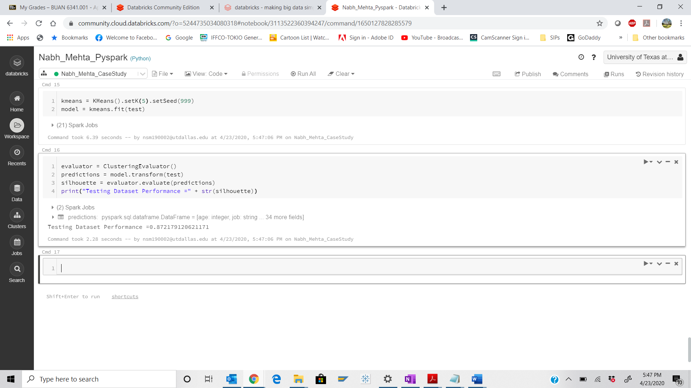

Step 26:

Export the file as “HTML” and save that with your “Firstname_Lastname” naming convention.

Convert this HTML file to PDF (This is your 2nd submission file)

Export as “IPNYB” file. (This is your 3rd submission file)

